**Verzeo**

**Microsoft Azure Cloud Computing**

**Minor Project**

*Name: Aarish Ahmed Siddique*

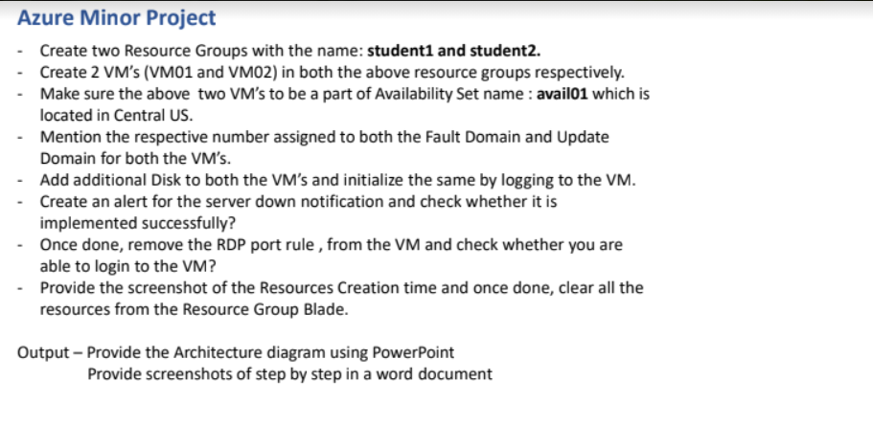

1. Created resource group student 1.

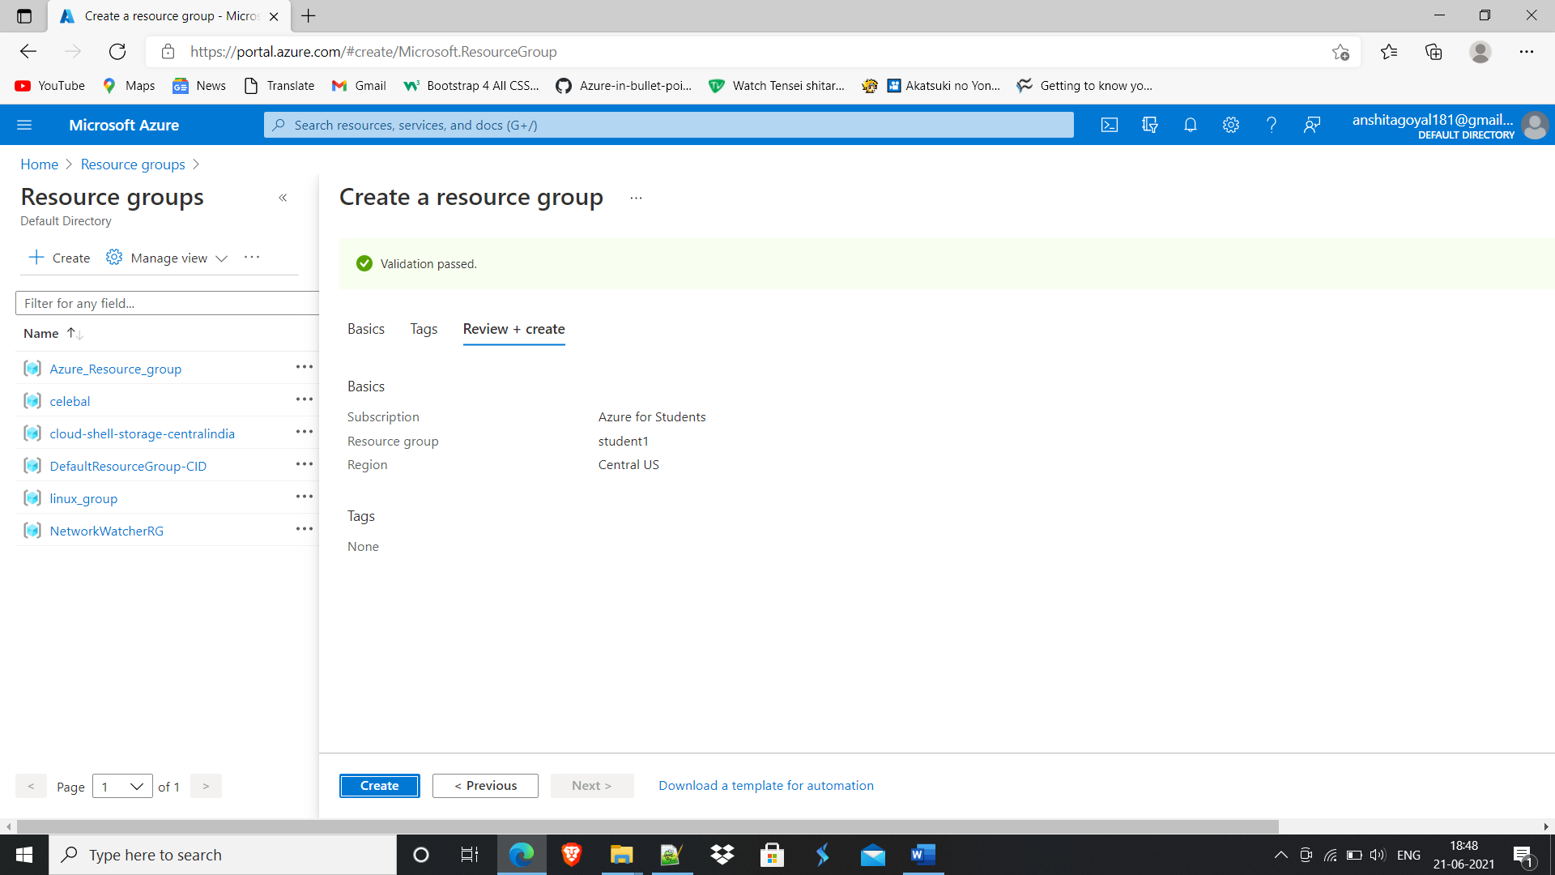

1. Created resource group student 2.

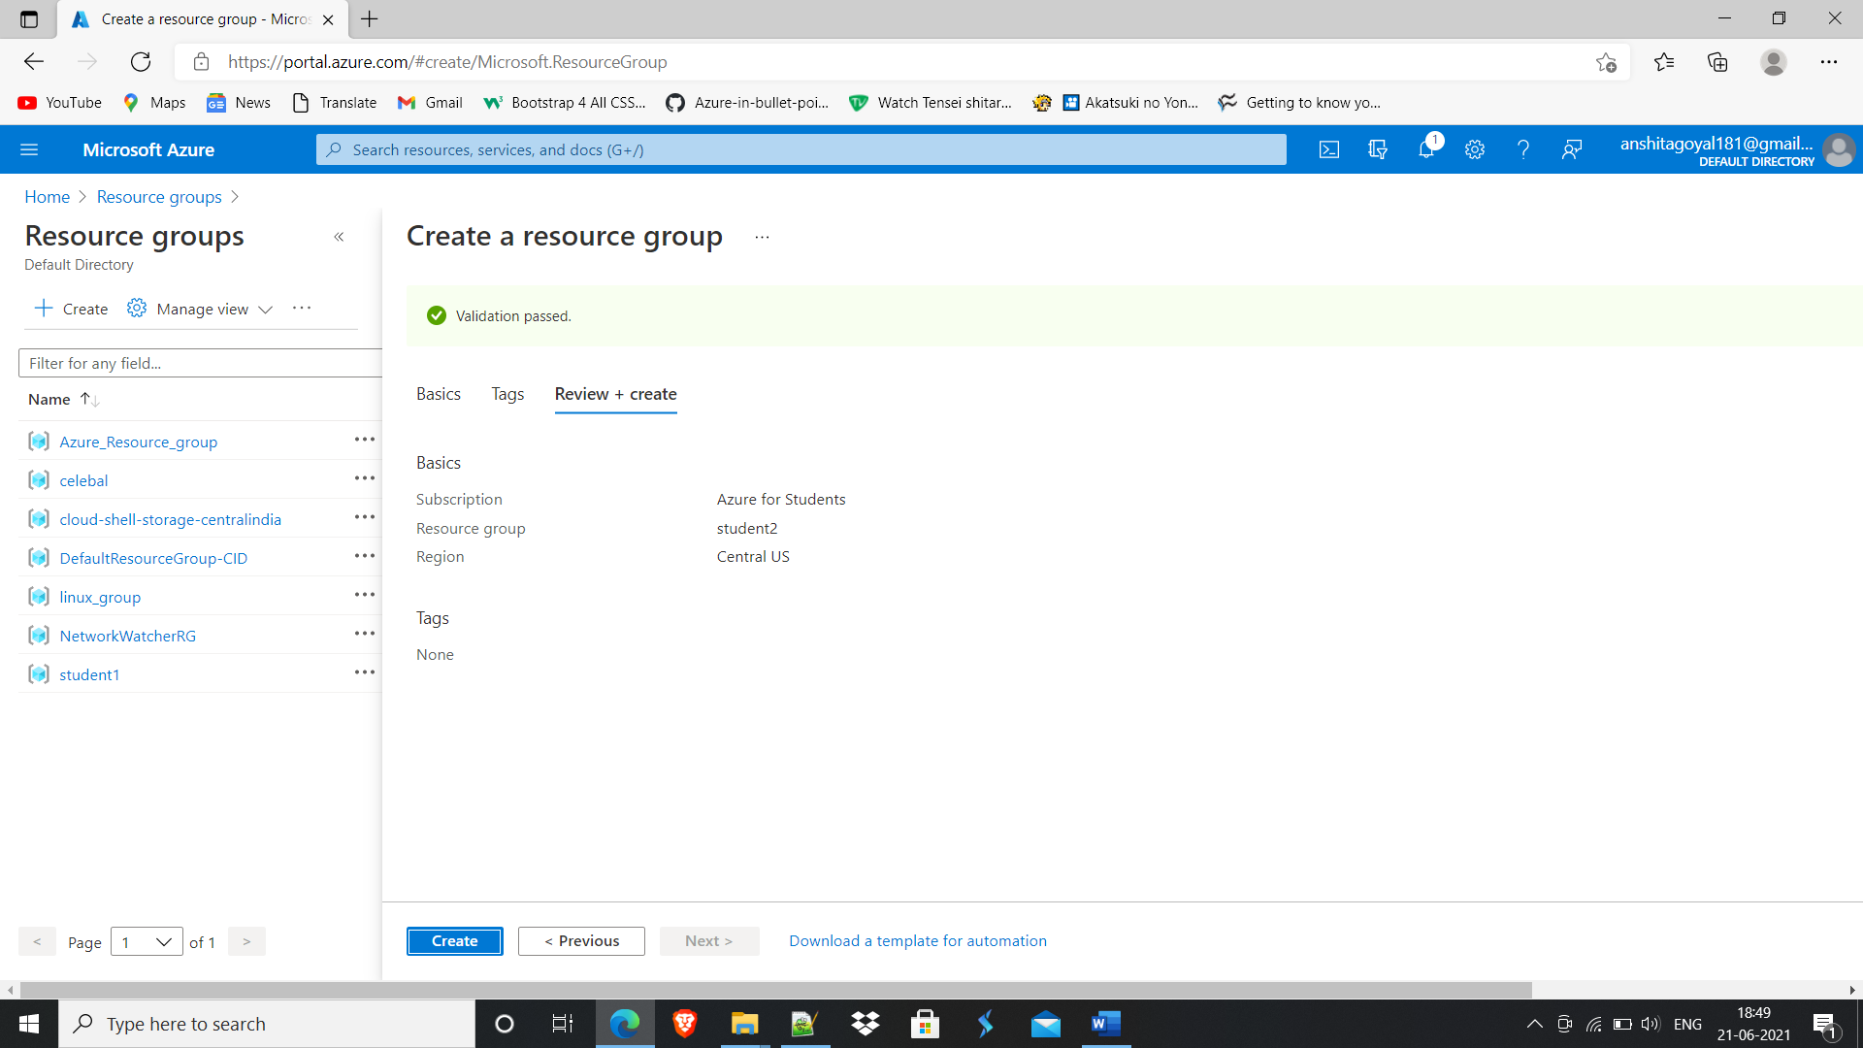

3. Created VM with name VM01 in student 1 resource group.

4. Created availability set avail01 with 2 fault domain and 5 update domains.

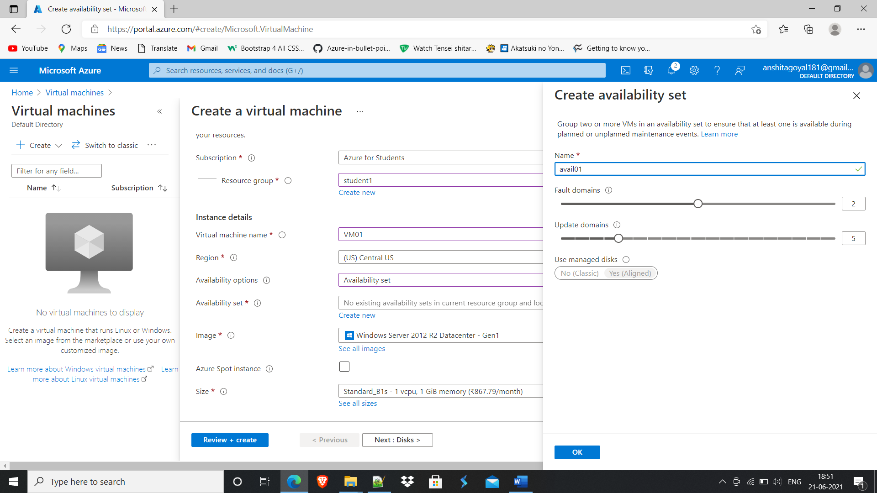

5. Added additional disk of size 4Gib.

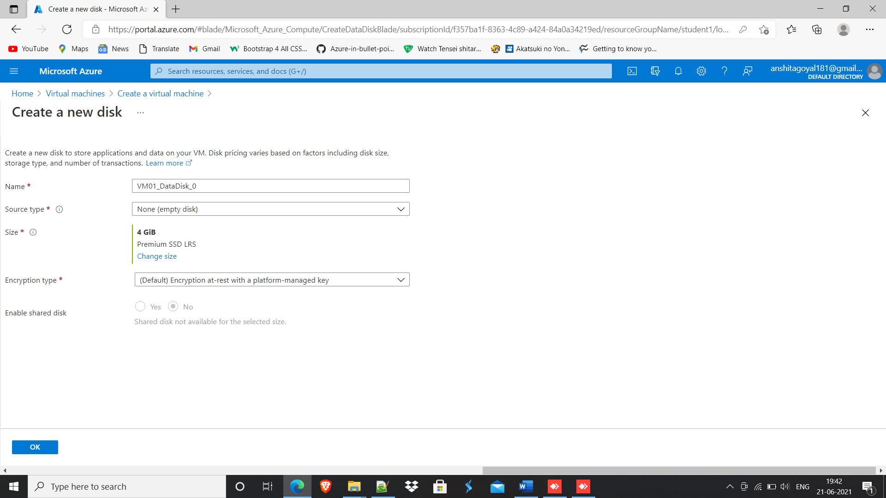

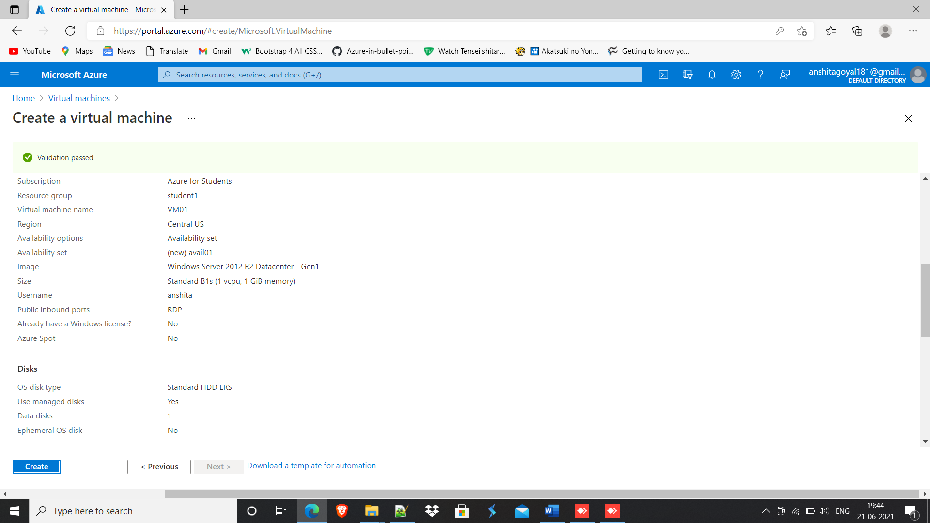

6. Similarly, created VM02 in student 1 and part of avail01.

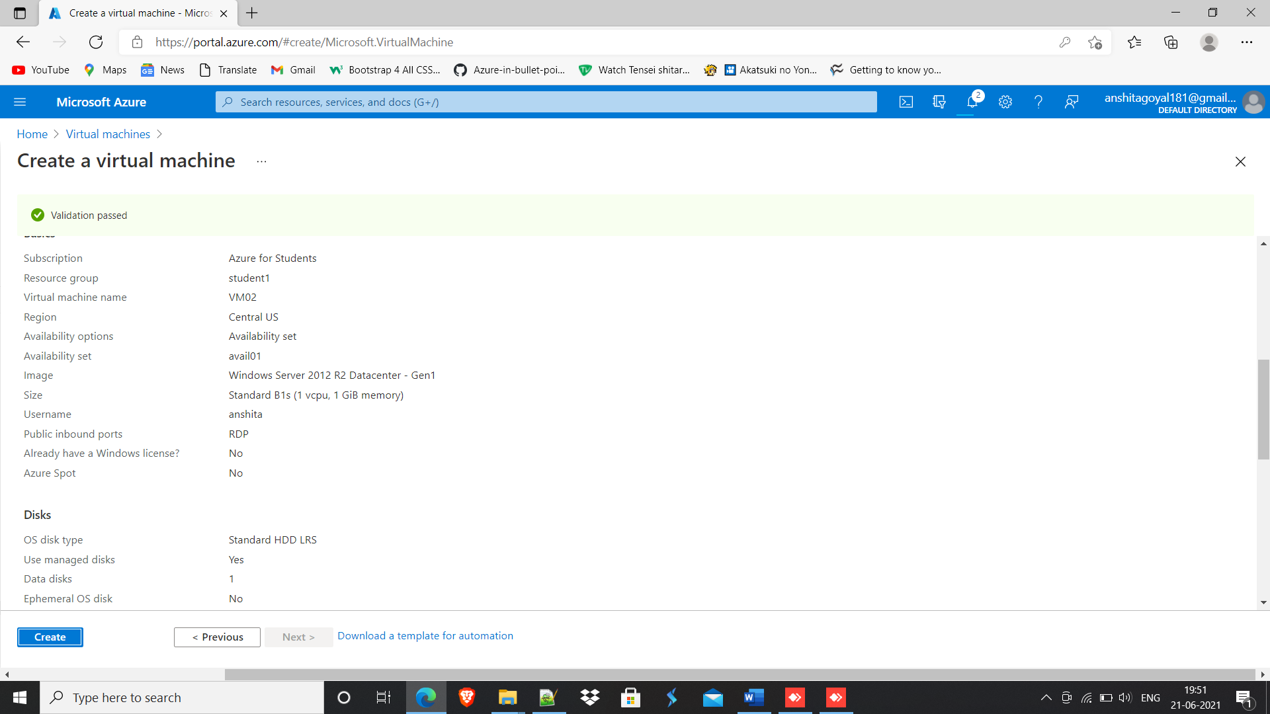

7. Similarly, created VM01 in student 2 and part of avail01.

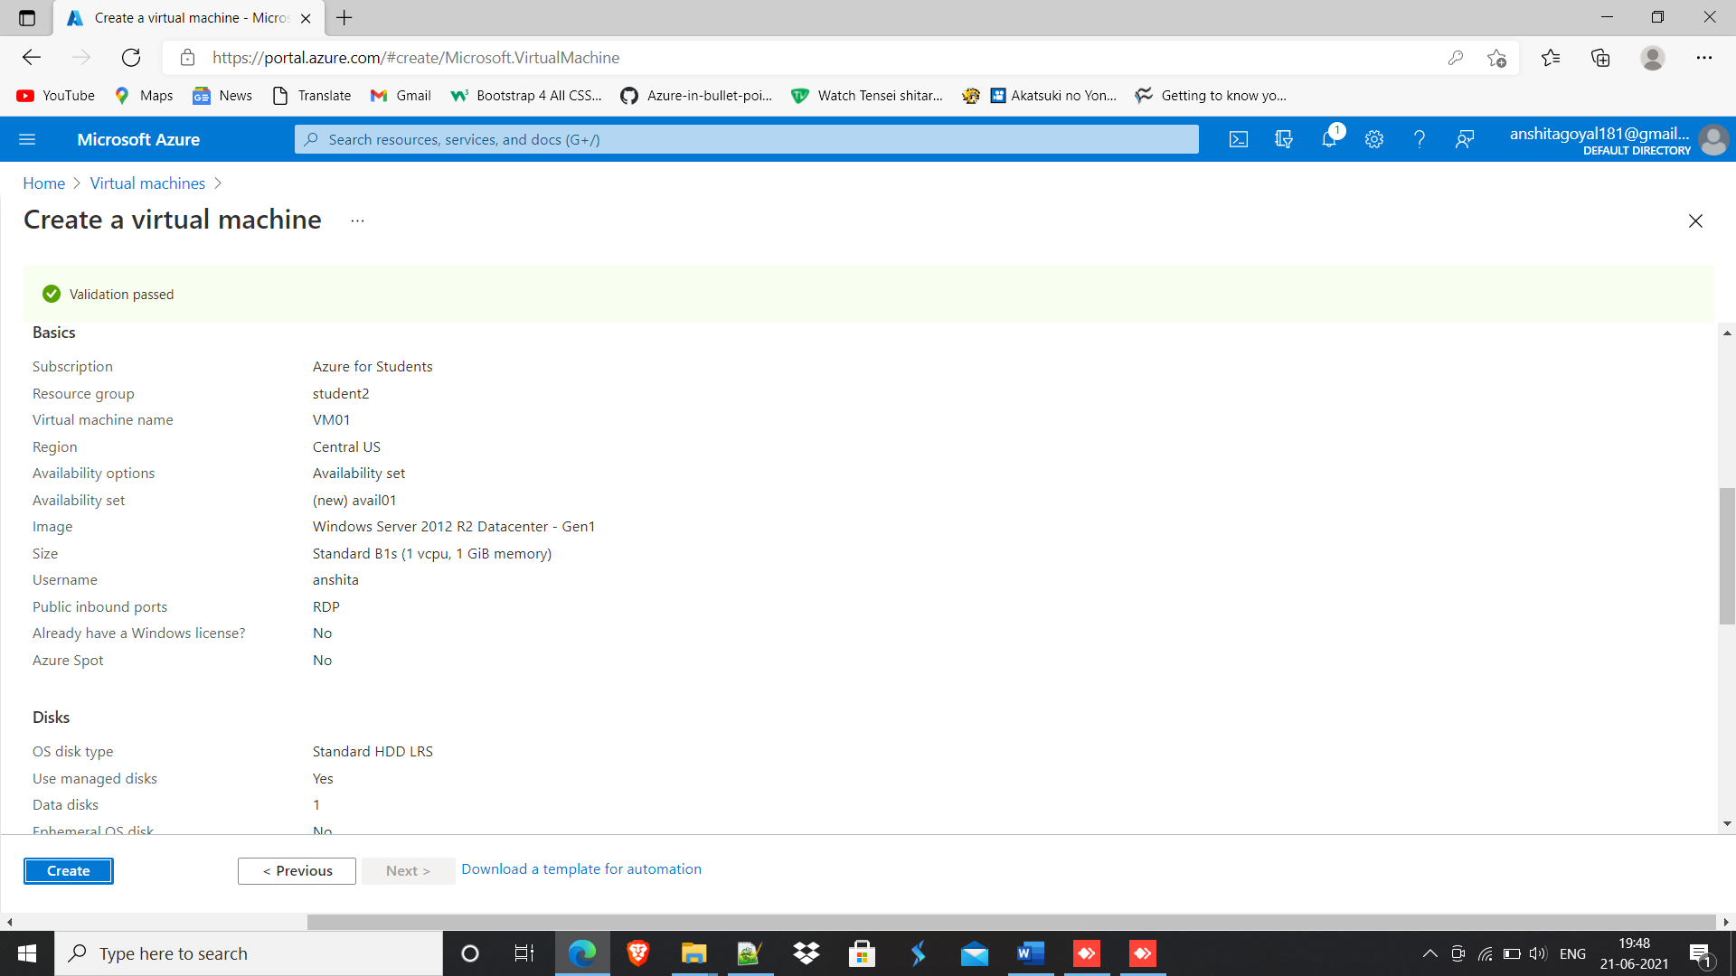

8. Similarly, created VM02 in student 2 and part of avail01.

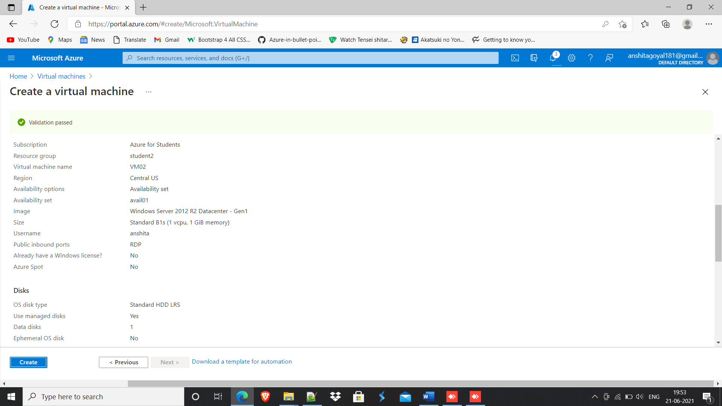

9. Created alert for server down.

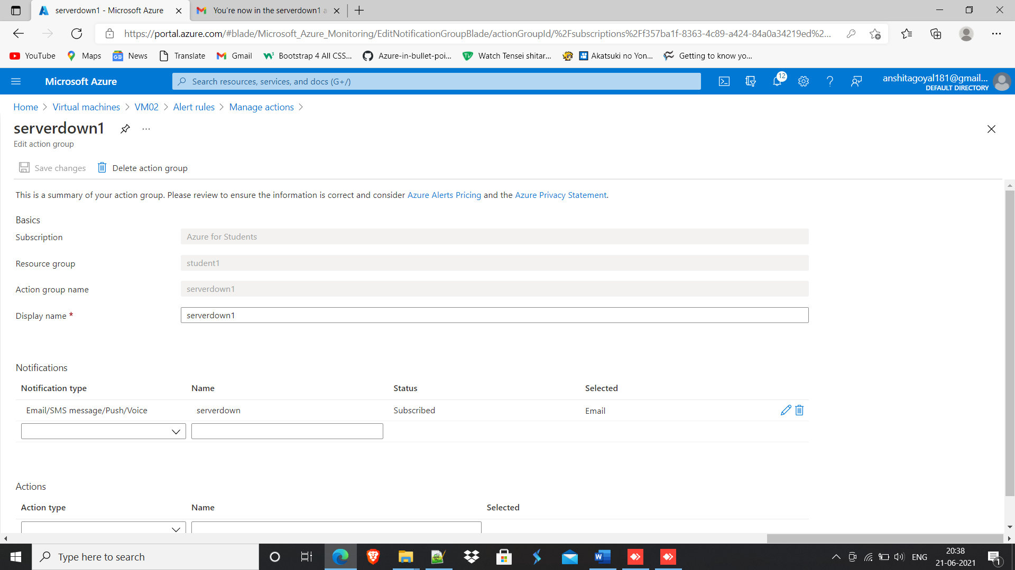

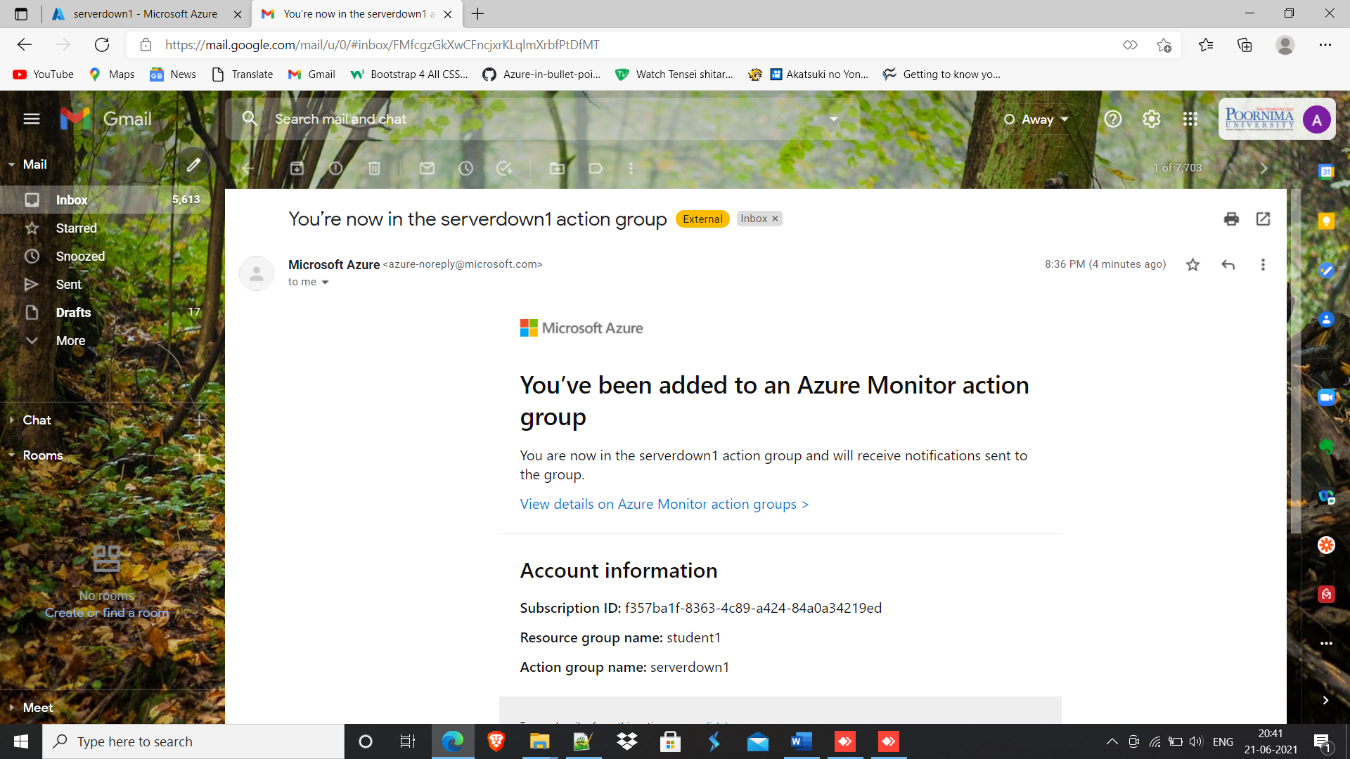

10. Removed RDP port rule in NSG.

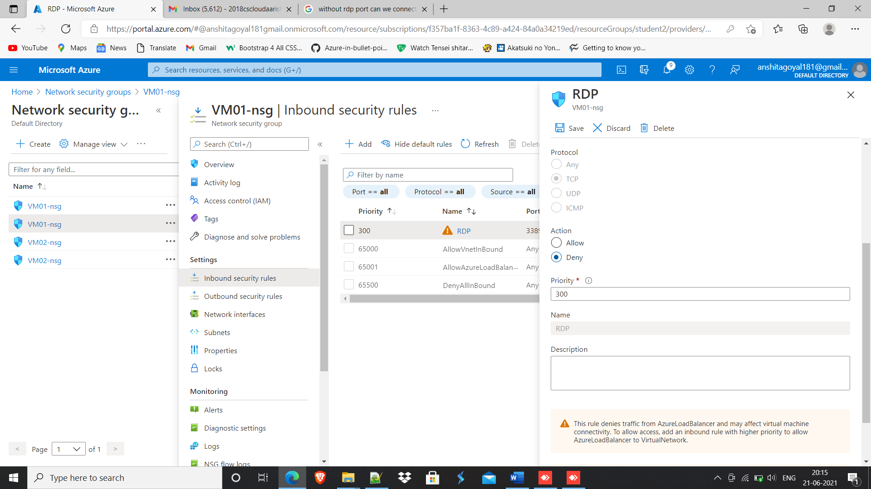

11. Cannot access VM because of removal of RDP port rule.

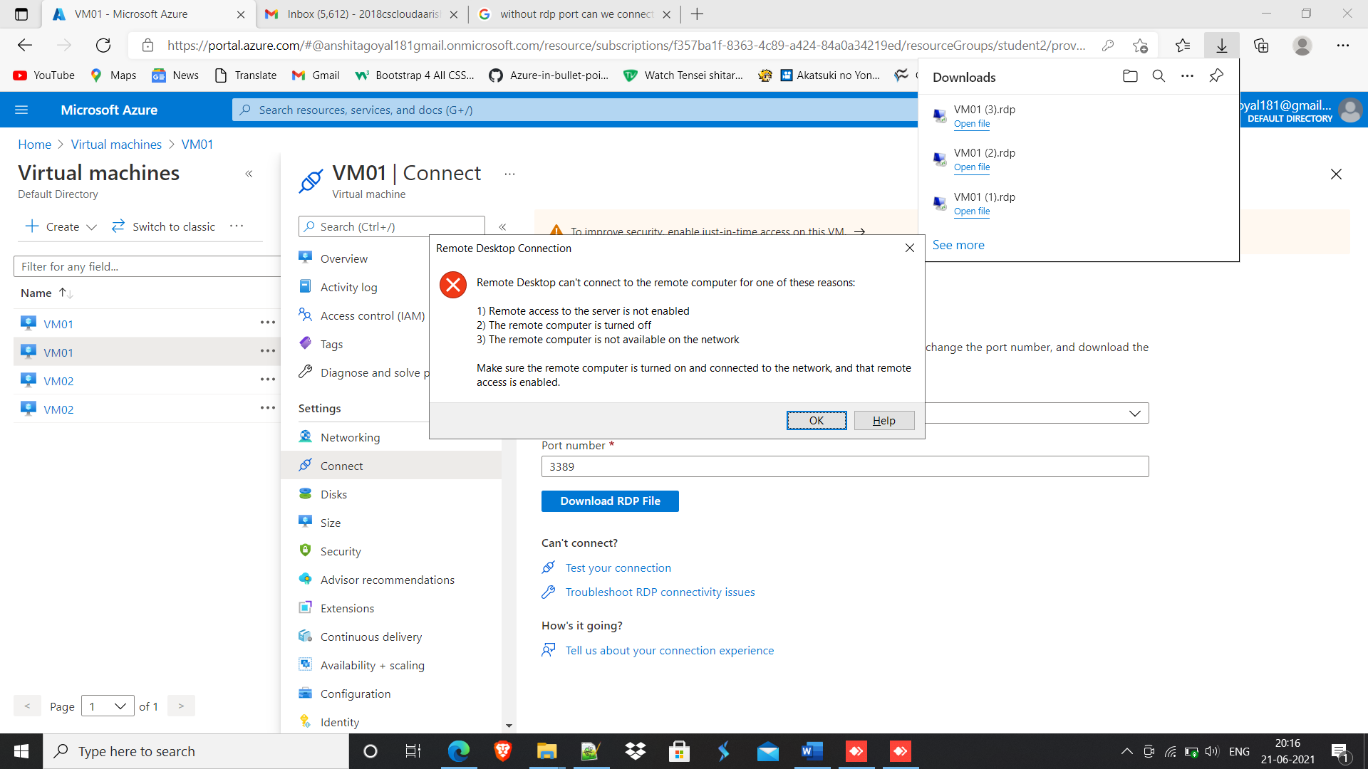

12. Resource creation time screenshot.

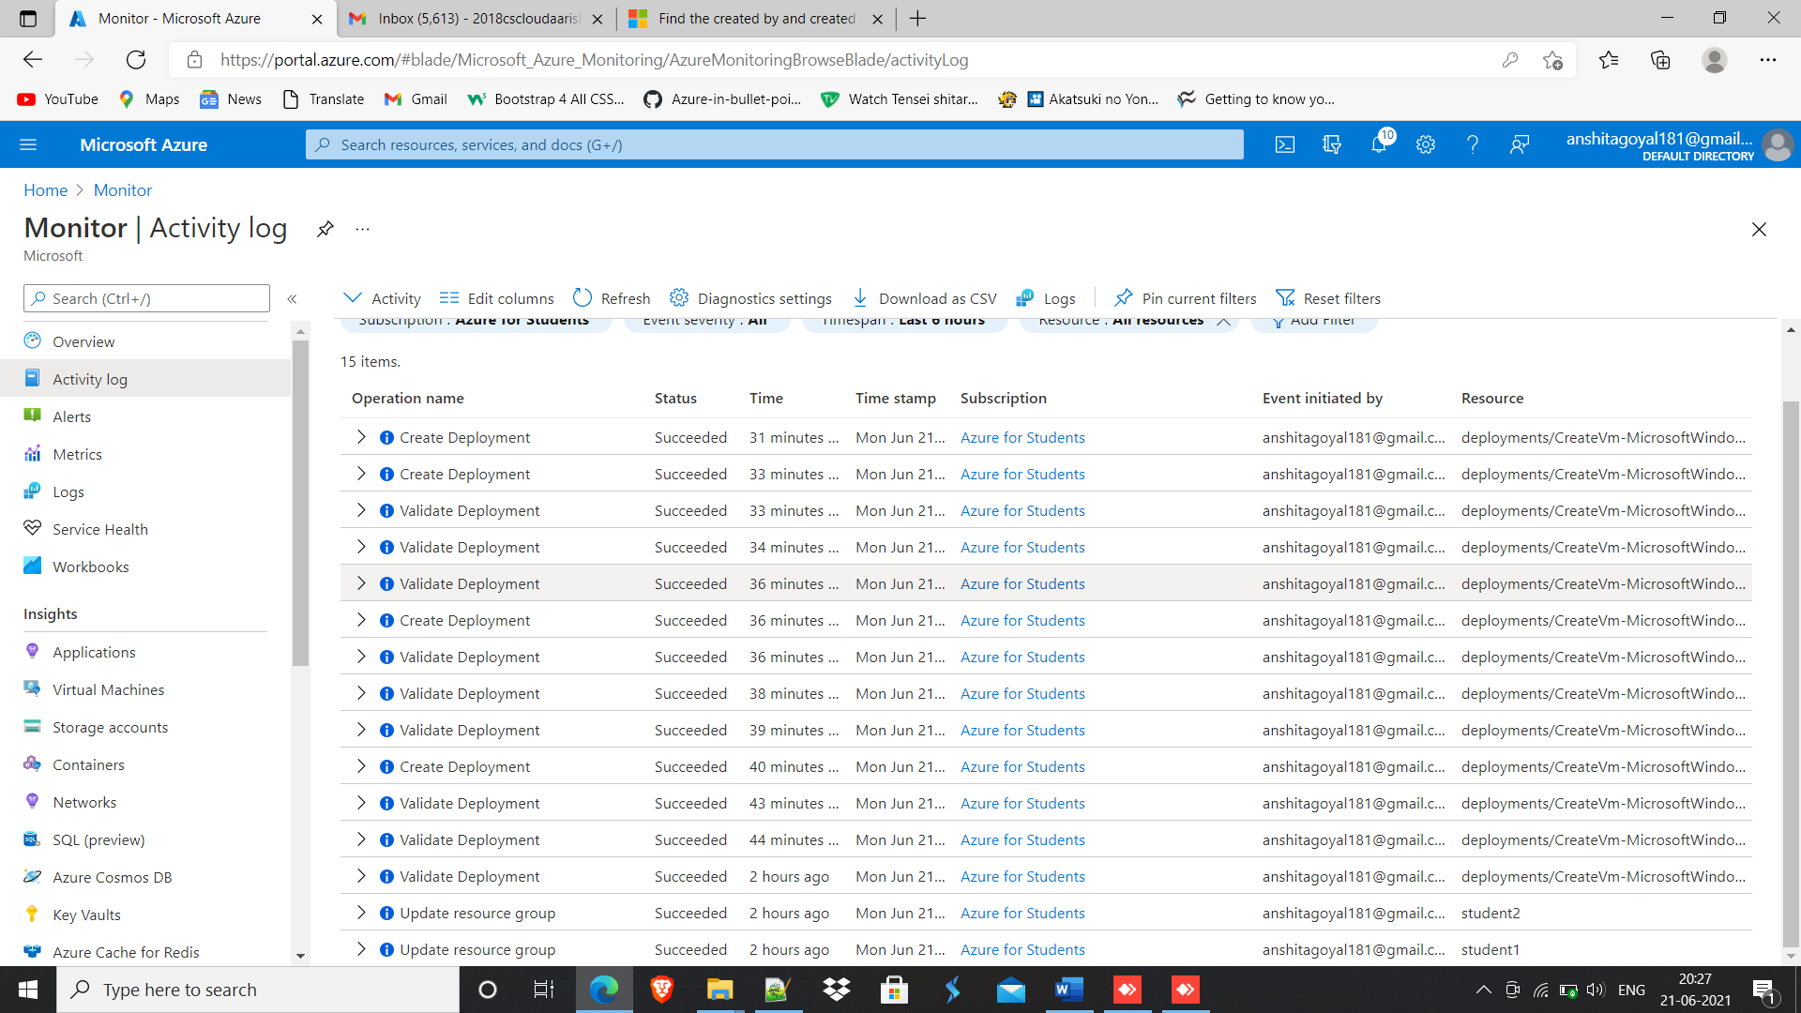

13. Deleted all resources

